## Merchant

Scoping start date: D&D partner

Implementation Completed Date (Go live date): Jun 11, 2024t

MSA Signature Date: Feb 7, 2024

GTM POC: Rebecca

Implementation POC: [Royce Kok](mailto:rkok@tabsplatform.com)

ERP: QBO

Sales / CRM : Zoho

Tax Integration: Avalara (Current systems is in QBO Taxes)

### 

### Key people at Merchant

### CEO: Brandon Peterson

### Sales Order automation: Taylor Williams

1. Tax expert: Dallas Polivka

### Smartsheet automation: Megan Rossman

1. Controller: Maya
2. AR person?

### Company summary

Geokey is a mobile access control software that allows users to open doors, gates, elevators, and padlocks right from their phone. By using their location services and logging into the app, users can easily get into their facilities seamlessly without a key or fob.  
  
AM Notes

Geokey is a large enterprise deal of Tabs with quite a number of disparate systems.

### Billing model

* Info on how merchant bills
  + [Tabs <> Geokey Kickoff](https://docs.google.com/presentation/d/1EKNvaJB018_IVLIaspGr_m9f7JCj6sJr8PMGGCErA3s/edit#slide=id.g1f4101dcda4_1_1)
  + [Geokey - Avalara - QBO | Flow Diagram](https://docs.google.com/presentation/d/1gTZB1CirqPxQ54CG7lq7lqwot5qAXq1viIz4Ysc4f_s/edit#slide=id.g2ccd100682c_0_0)
  + 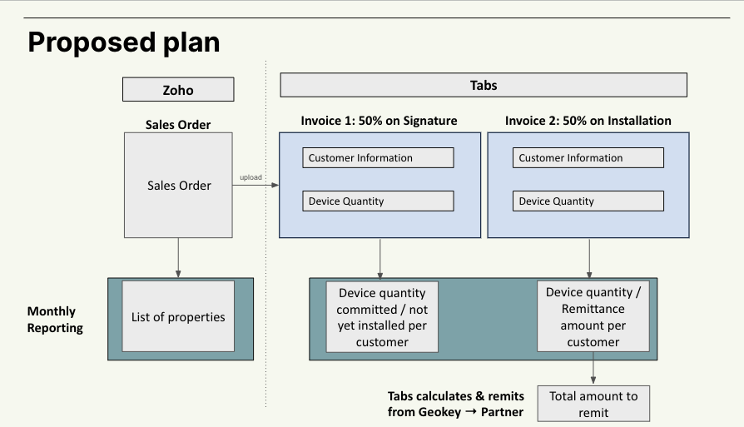
  + 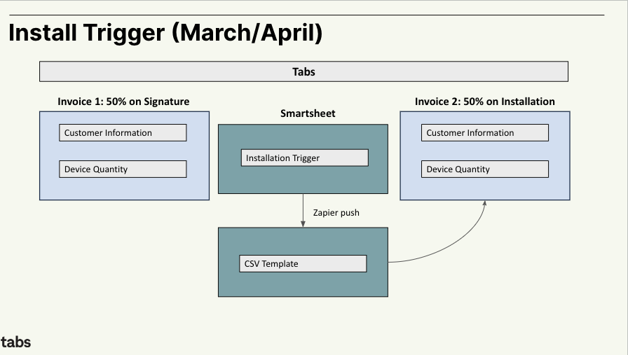
  + How contract is broken up
    - Sales Order comes directly from Zoho (this is their version of a contract)
      * First half of the invoice goes out on the signature
      * Second half of the invoice goes out on the installation date (which gets pick up on Smartsheet automation)
    - **Tax:** Don’t need to populate the tax info (as a billing term) as part of contract ingest.
  + One off things to know about merchant
    - Lots of stakeholders
    - Various systems that we’re trying to piece together

### Contract Processing Steps

1. DO NOT PROCESS any files starting with INV-<X>,   
   ONLY PROCESS files starting with SO-<X>
   1. IF File starts with SO-<X> before processing - check garage to see if an identical SO has been uploaded and processed previously. If an identical SO has been processed previously, DO NOT PROCESS.
2. If creating a customer, please make sure to add the address.
   1. Under reference # in the sales order, if there is a name, please create a subcustomer in QBO.
   2. 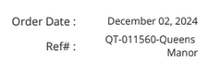 Queens Manor becomes the subcustomer here
3. There are 2 different workflows that we need to support. ››
   1. Sales Order + Purchase Agreement (Flow 1 - more complex)
   2. Sales Order only (Flow 2 - simple)
4. When a Sales Order comes in, the terms and conditions will either reference a Purchase Agreement or will not. You can identify under Terms & Conditions if it’s Flow 1 (says “purchase order”) or Flow 2 (does not specify purchase order)
5. Default: Net 0
6. Pull the Geokey "Project ID" out of the SO Field "Reference #" (where populated)
   1. Tabs will map the "Project ID" to one of Tabs' Custom "additional fields" specifically the "project name" field.
   2. IF POSSIBLE: The reference number field is sometimes comprised of a "Quote Number" + "Project ID" - we should default to including all data from this field, but if possible, Geokey would prefer that we exclude the "Quote Number"
   3. Quote Number Example (to Exclude): for example on SO-1774 the Reference field is "QT-011479 (Citylight - Midtown)". Ideally the project would just be "Citylight - Midtown".
7. If the team gets a duplicate INV ID, please delete the old contracts and reprocess the new contracts that come into the system. These should be relatively small % where duplicate contracts are actual changes to the invoices terms.

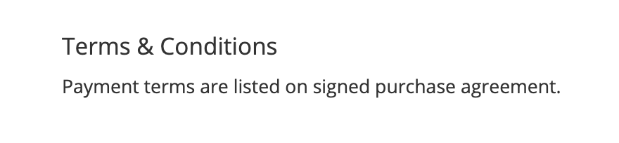

**Flow 1 (Sales Order + Purchase Agreement)**

1. Good reference contracts and loom video
   1. Loom video here - <https://www.loom.com/share/76a41271b38d47389e9bee31999c893d>
   2. Reference contracts
      1. Purchase Agreement: 970c09bc-e7d4-4bd1-b80d-6ecad1e115c9
      2. Sales Order: a201414f-7b58-4a6f-b9d4-692b93570d78
2. There should be 2 documents - Sales Order & Purchase Agreement. Use the Sales Order for billing terms and use the Purchase Agreement to pull out the dates.
   1. Please wait for the secondary document “Purchase Agreement” to come to Tabs before processing.
   2. It should come in within 1 hour of the Sales Order being sent to Tabs.
   3. Please escalate to your manager if you do not notice the Purchase Order when the Sales Order says that they should be one.
3. The purchase agreement will contain 2 sections of relevance. The payment rules on the first page and the payment schedule on the last pages.
4. **Payment Rule example on first page (breakdown by %)** 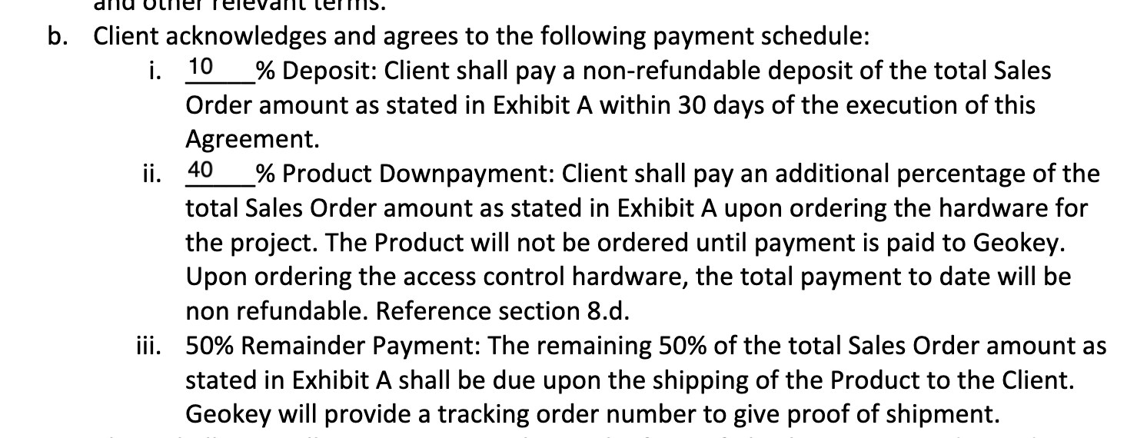
5. **Payment schedule on last page (dates for invoicing)**

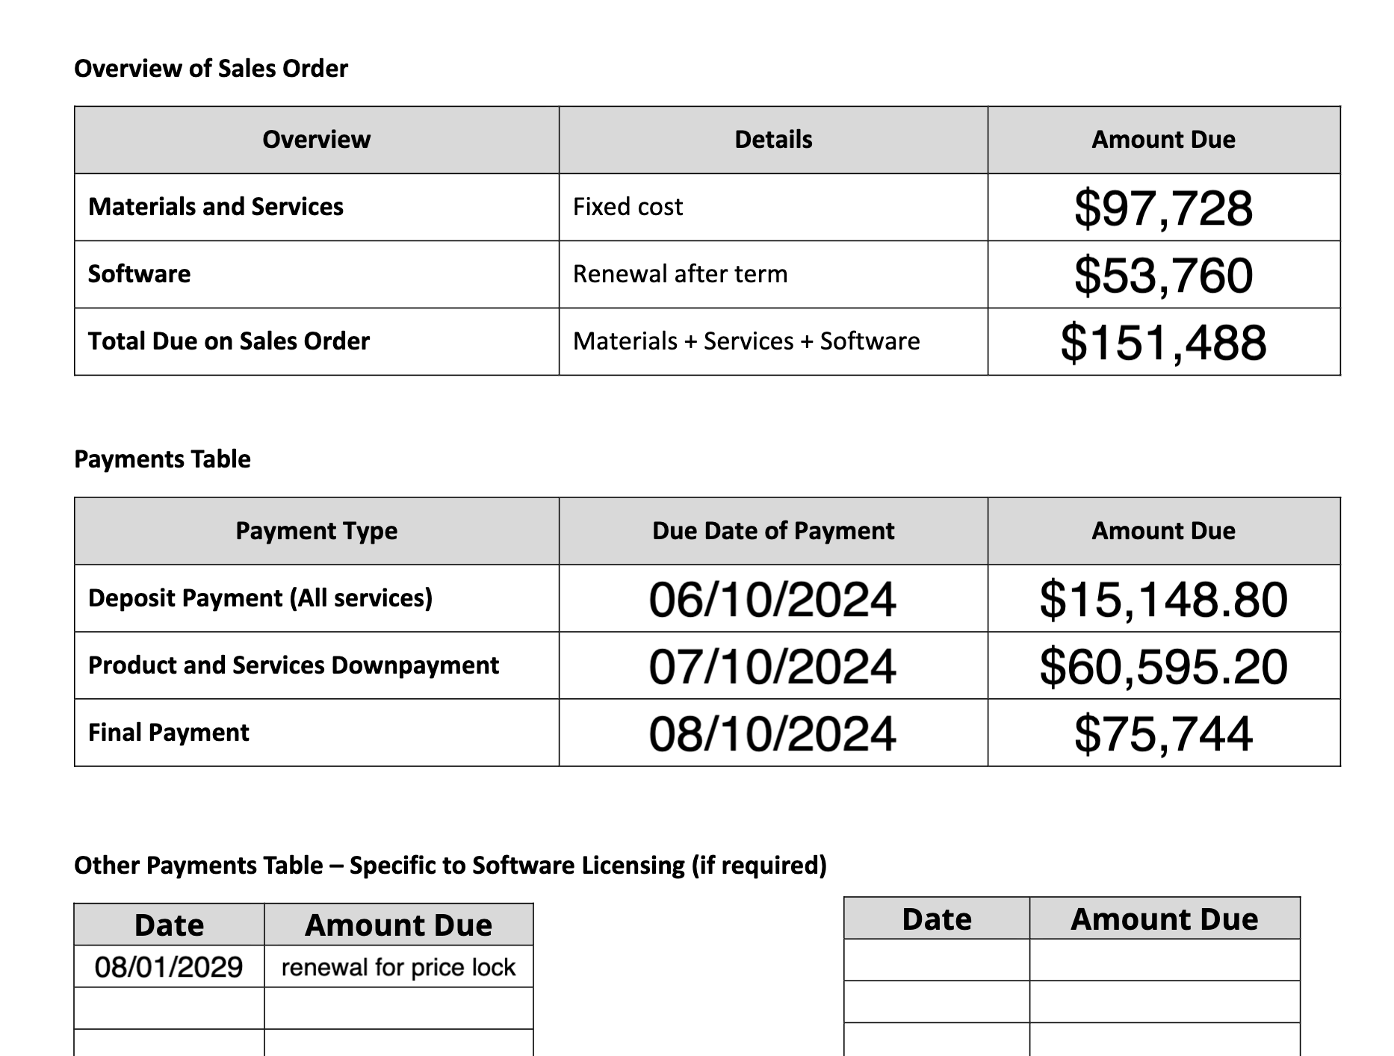

1. There are a few types of schedules:
   1. Deposit and Downpayment - This almost always refers only to hardware materials and services but please read the fine print.
   2. Final Payment - This is normally inclusive of software.
   3. Other Payments - Either the software invoice date if not defined elsewhere or the renewal date.
2. The prices are inclusive of taxes whereas, you **should not** be adding any tax line items to your billing terms. If the numbers are off, please escalate to your manager.

Flow 2 (Invoice only)

1. There should only be one document for the Invoice Only flow.
2. Each line item in the sales order will specify how it should be billed. If nothing specified, assume non-recurring on the Invoice Date under “Terms and Conditions”, otherwise use the Billing/Order Date.
   1. For instance, if a line item shows (Term Quoted: 3-year, price lock agreement if renewed (paying 2-years up front), Divide the total in the “amount” column by 3, and create two billing terms, one worth ⅔ of the total on the Billing Date, and the last ⅓ on the 2 year anniversary of the billing date. Both non recurring.

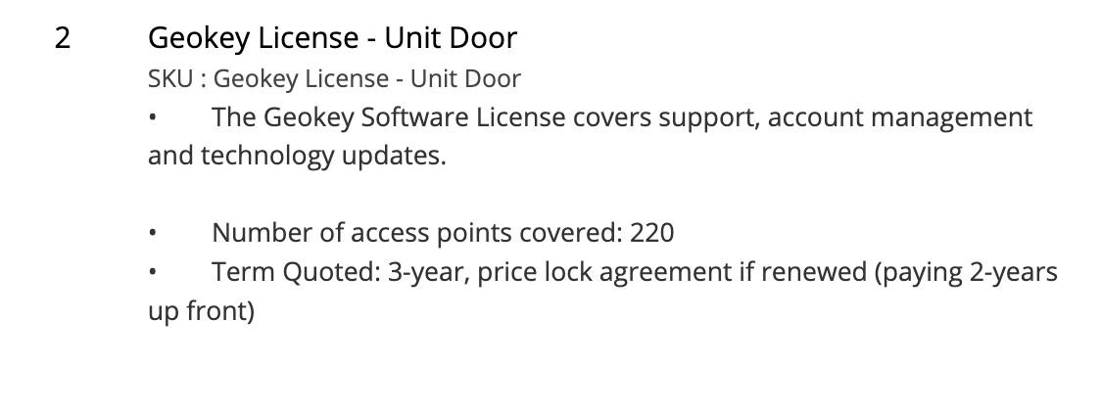

* 1. Invoice generated in garage may be calculated with different tax values from Avalara. Until we expose the subtotal - tax in garage, you cannot assume the invoices total will always match the sales order given the tax difference.

### Events Processing (if necessary)

* None

### Customer Information

* Any important information on specifics customers of this merchant
  + Special memo’s certain invoices require
  + Invoice changes due to merchant/customer relationship

### Feature Requests

* FR 1
  + What is it
  + Why it's important
  + Urgency

### Rewatch Calls

* Rewatch by dates